AI ASSISTED CODING
LAB-16: Database Design and Queries: Schema Design and SQL Generation
Name: Simra Tahseen
Roll no: 2503A51L17
Batch: 25BTCAICSB19

Task-1 Description: Schema Generation
Task: Ask AI to design a schema for a Library Management System (Tables: Books, Members, Loans).
Prompt: Design a schema for a Library Management System (Tables: Books, Members, Loans).

Code Generated:

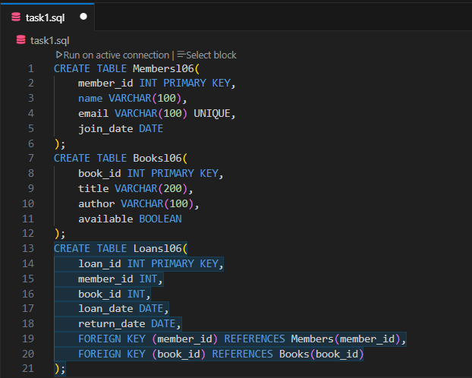

Observation:
Three tables — Members, Books, and Loans — were created to manage library data. They are linked using foreign keys to track which member borrowed which book.

Task-2 Description: Error Insert Data

Task: Ask AI to generate INSERT INTO queries for the schema above (3 sample records per table).
Prompt: Generate INSERT INTO queries for the schema above (3 sample records per table).

Code Generated:

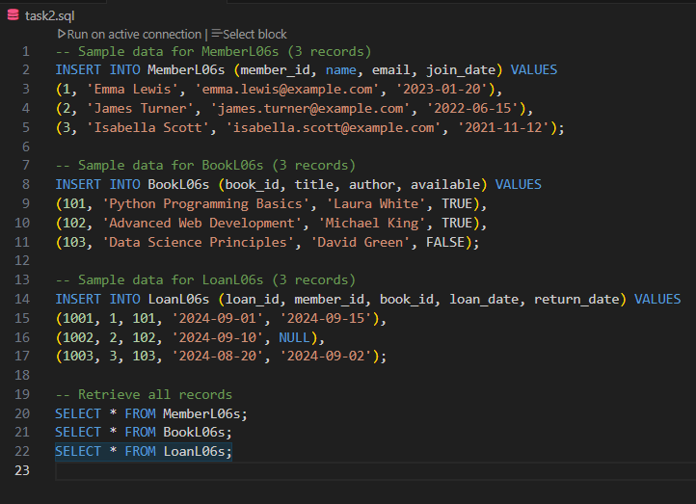

Output:

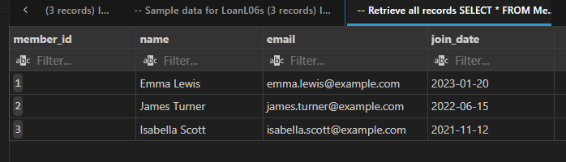

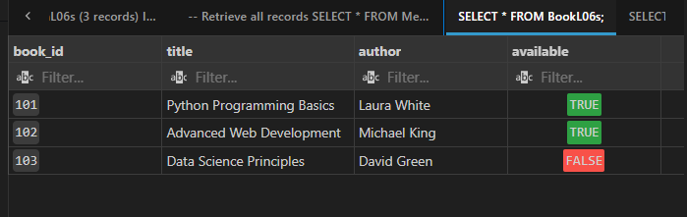

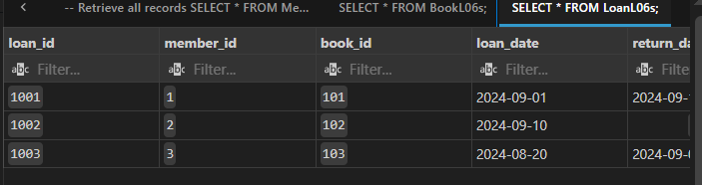

Observation:
Three tables — MemberL06s, BookL06s, and LoanL06s — were successfully created and populated with 3 sample records each. The INSERT and SELECT queries executed without duplication errors, and the retrieved data correctly displayed members, books, and their loan details.

Task-3 Description: Basic Queries
Task: Use AI to generate a query to list all books borrowed by a specific member.
Prompt: Generate a query to list all books borrowed by a specific member.
Code Generated:

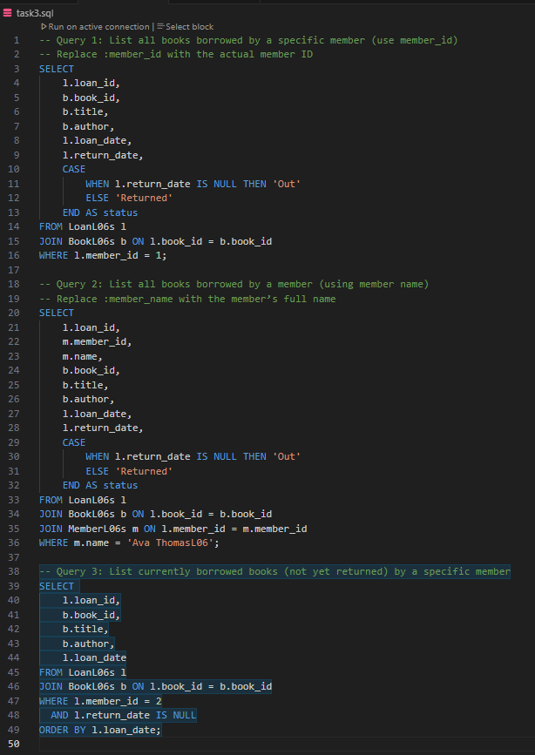

Output:

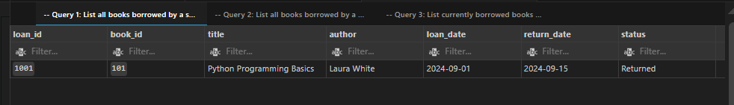

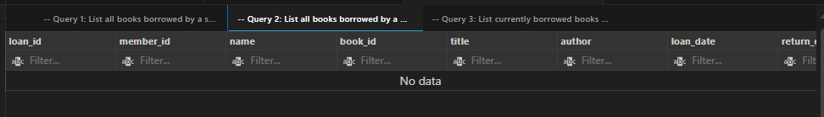

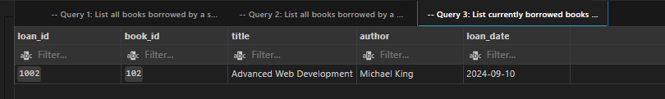

Observation:

The queries successfully retrieve books borrowed by specific members, show loan status (Out or Returned), and list currently borrowed books using joins between MemberL06s, BookL06s, and LoanL06s tables.

Task-4 Description: Update and Delete Queries
Task: Generate queries with AI for:
- Updating a book’s availability to FALSE when borrowed.
- Deleting a member record safely.
Prompt: Generate queries for: Updating a book’s availability to FALSE when borrowed.

Code Generated:

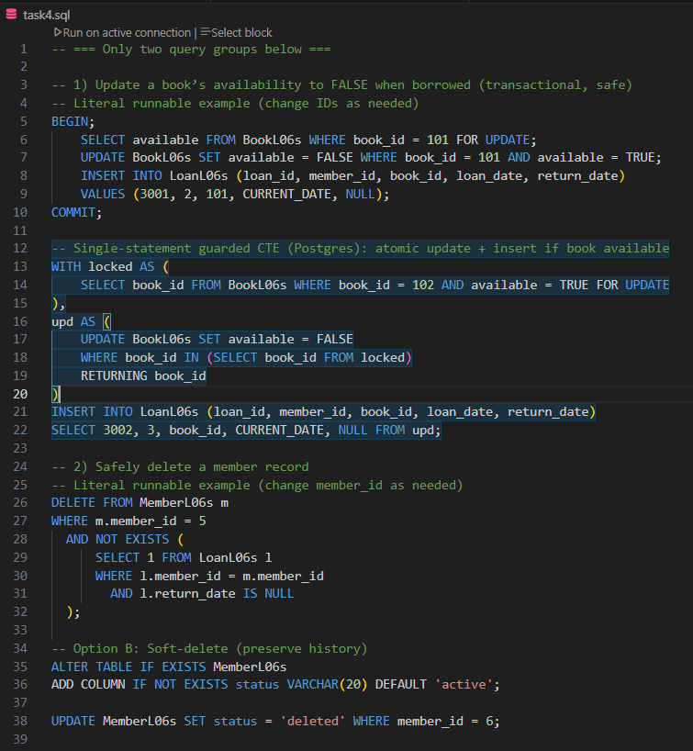

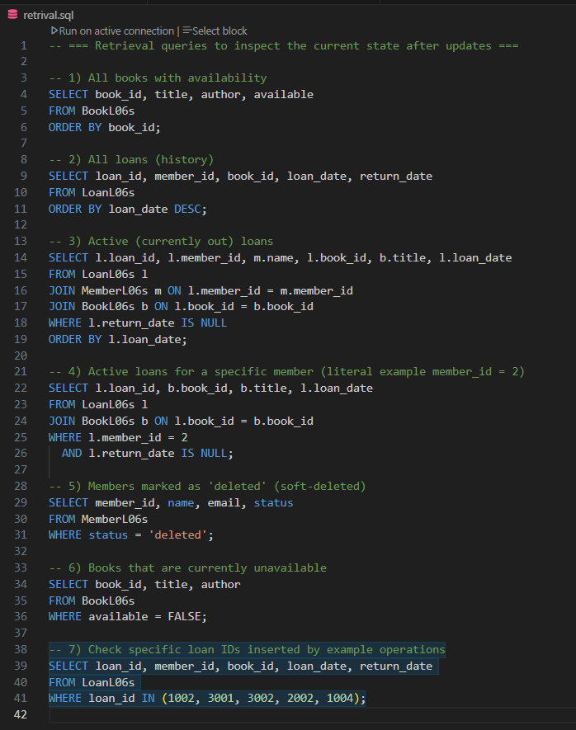
- Deleting a member record safely.

Ouput:
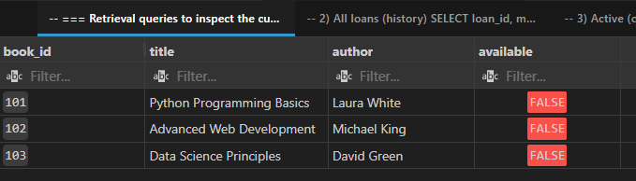

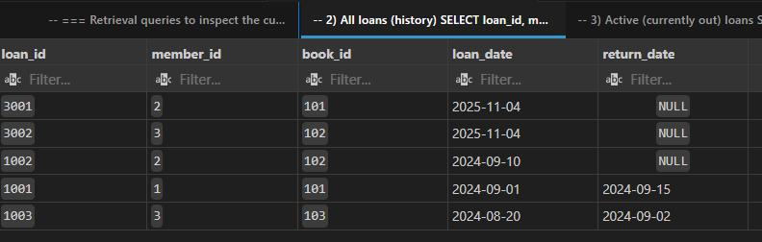

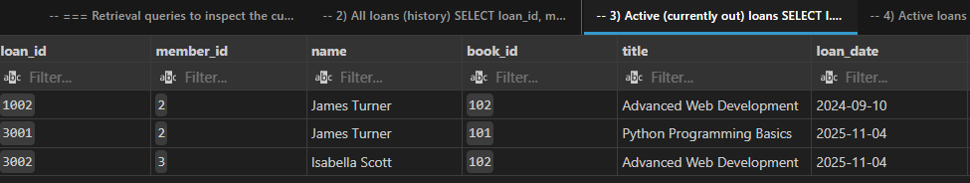

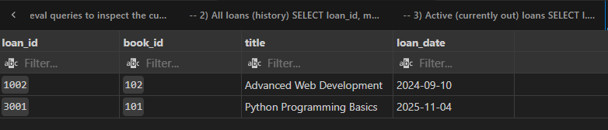



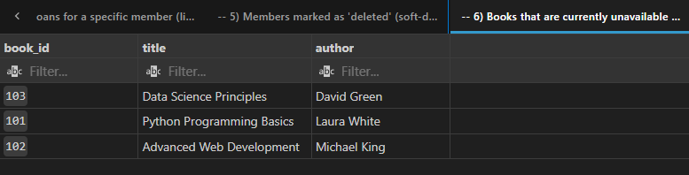

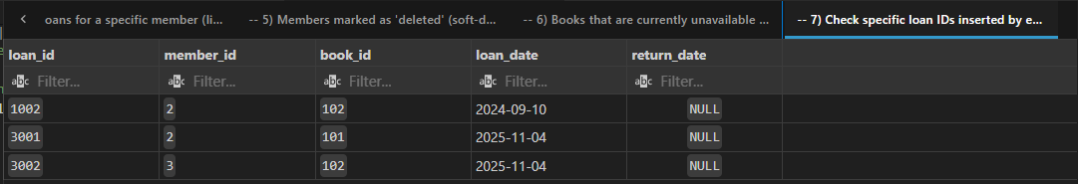

Observation:
The update and delete queries in Task 4 correctly modify the database by marking books as unavailable when borrowed and safely deleting member records. The retrieval queries verify these changes by displaying updated book availability, loan history, and deleted members, confirming that all operations execute successfully and maintain data integrity.

